|  |
| --- |
|  |
| CSC301 VISUAL PROGRAMMING |
| **GROUP PROJECT** |
|  |
|  |
|  |

|  |  |  |  |  |
| --- | --- | --- | --- | --- |
|  |  | |  | |
| **LECTURER’S NAME** | **:** | | NOR HASNUL AZIRAH BT ABDUL HAMID | |
| **GROUP MEMBERS** | **:** | |  | |
|  | |  | |
| **STUDENT ID** | | **NAME** | |
|  | |  | |
|  | |  | |
|  | |  | |
|  | |  | |

# DESIGN OF THE PROPOSED SYSTEM

## SCREENSHOT OF THE PROPOSED SYSTEM

Label below each of the screenshot. E.g Figure 3.3.1: Homescreen, Figure 3.3.2: Log in, etc.

## PROPERTIES OF THE PROPOSED SYSTEM

Properties must be in table. Must list down all the controls types, name, description/functionality, and Text Property of the proposed system. Refer textbook – *Page 18*.

Table must be labelled and follow the subtopic numbering. E.g if table under subtopic 3.4 Properties, the naming should be: Table 3.4.1 *System_Name* Controls (above the table).

*Example of properties table:*

Table 3.4.1 *Wage Calculator* Controls

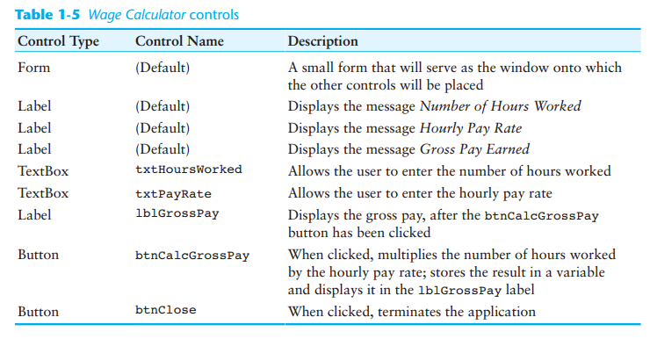

## CODING OF THE PROPOSED SYSTEM

**Formatting:**

Typeface: Courier New

Size: 10

Spacing: 1.0

## SCREENSHOT OF THE DATABASE TABLES’ OF THE PROPOSED SYSTEM

Labeled. E.g Table 4.3.1 Admin table